🩺 Diabetes Prediction — SQL Analytics Project Report
Author: Rohan Kumar Jha
Tools Used: MySQL Command Line Client, MySQL Workbench
Dataset: Diabetes Prediction Dataset (Kaggle)

🧭 1. Project Overview
This project analyzes a medical dataset containing diagnostic measurements used to determine whether a patient is likely to have diabetes.
The goal is to:
- Explore medical and lifestyle indicators
- Identify patterns associated with diabetes
- Build SQL-based analytical insights
- Perform segmentation and risk scoring
- Create a clean, professional analytics report
This project demonstrates:
- SQL data import
- Data validation
- Exploratory analysis
- Medical risk analytics
- Feature engineering
- Clean, structured reporting

📦 2. Dataset Description
The dataset contains 768 patient records with medical measurements commonly used in diabetes diagnosis.
Column Definitions
Column Name | Description
Pregnancies | Number of times pregnant
Glucose | Plasma glucose concentration
BloodPressure | Diastolic blood pressure (mm Hg)
SkinThickness | Triceps skin fold thickness (mm)
Insulin | 2-hour serum insulin (mu U/ml)
BMI | Body mass index
DiabetesPedigreeFunction | Genetic diabetes likelihood score
Age | Age in years
Outcome | 1 = diabetic, 0 = non-diabetic
Why this dataset is valuable
- Realistic medical domain
- Perfect for SQL + ML-style feature engineering
- Clean numeric data
- Ideal for risk scoring and segmentation
- Strong portfolio impact

🧱 3. Database & Table Creation
Create database
CREATE DATABASE diabetes_data;
USE diabetes_data;
Create table
CREATE TABLE diabetes (
Pregnancies INT,
Glucose INT,
BloodPressure INT,
SkinThickness INT,
Insulin INT,
BMI FLOAT,
DiabetesPedigreeFunction FLOAT,
Age INT,
Outcome INT
);
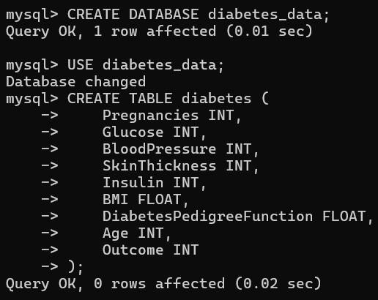

🖥️ 4. Importing the Dataset Using CMD
Move your CSV to:
C:\Users\itsro\OneDrive\Desktop\diabetes.csv
Import command
USE diabetes_data;

LOAD DATA LOCAL INFILE 'C:\\Users\\itsro\\OneDrive\\Desktop\\diabetes.csv'
INTO TABLE diabetes
FIELDS TERMINATED BY ','
ENCLOSED BY '"'
LINES TERMINATED BY '\n'
IGNORE 1 ROWS;
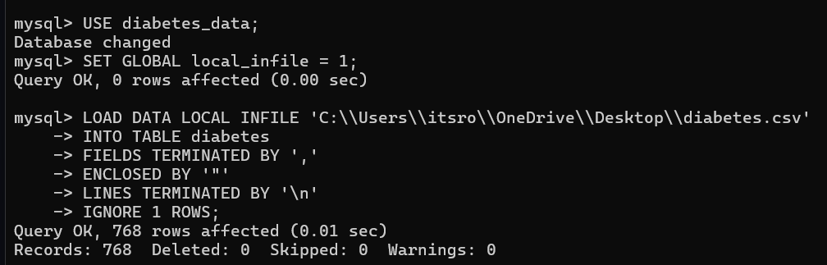

🔍 5. Data Validation in MySQL Workbench
Display first 5 rows
SELECT * FROM diabetes LIMIT 5;
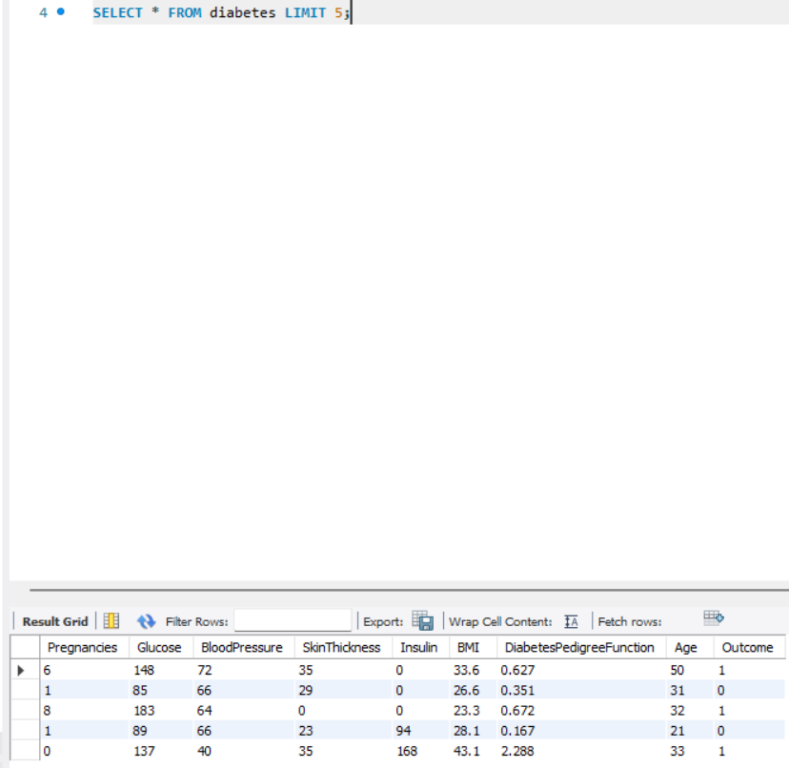
Count total rows
SELECT COUNT(*) FROM diabetes;
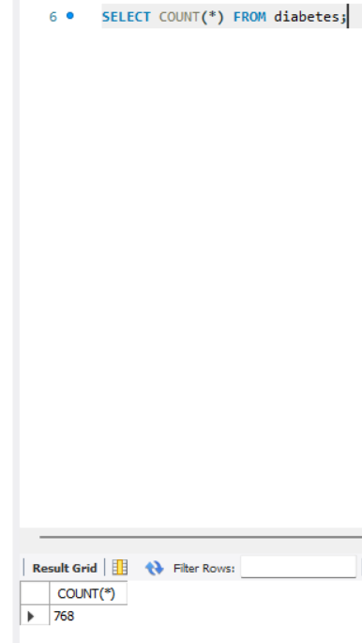
📘 6. Basic SQL Analysis (10 Tasks)

1. Count diabetic vs non-diabetic patients
SELECT Outcome, COUNT(*) AS total
FROM diabetes
GROUP BY Outcome;
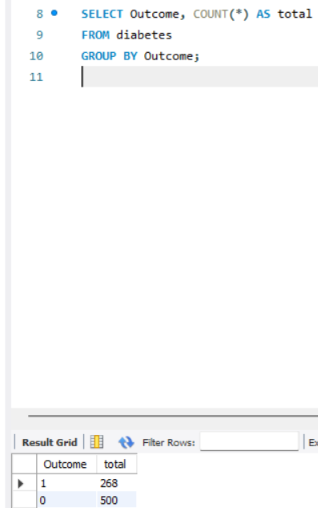

2. Average glucose level
SELECT AVG(Glucose) AS avg_glucose
FROM diabetes;
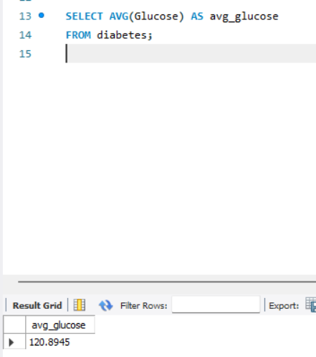
3. Average BMI
SELECT ROUND(AVG(BMI), 3) AS avg_bmi
FROM diabetes;
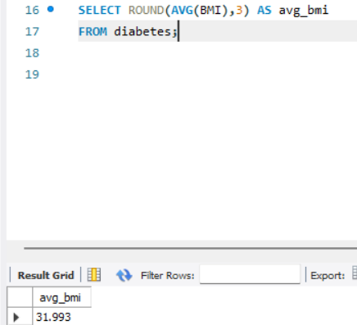
4. Patients with high glucose (>140)
SELECT *
FROM diabetes
WHERE Glucose > 140;
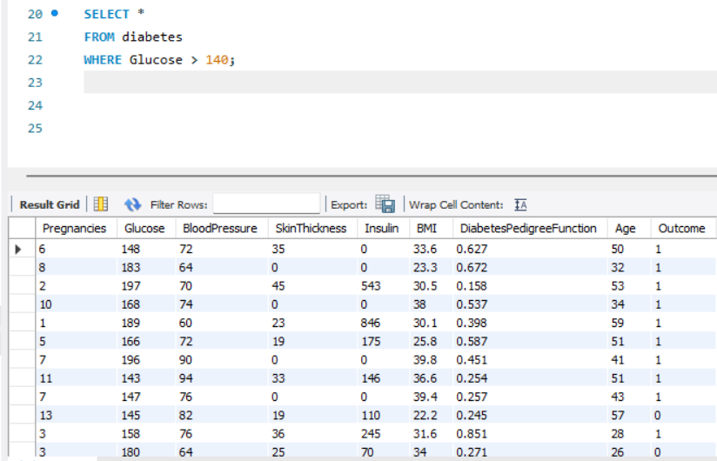

5. Count patients by age group
SELECT
CASE
WHEN Age < 30 THEN 'Young'
WHEN Age BETWEEN 30 AND 50 THEN 'Middle Age'
ELSE 'Senior'
END AS age_group,
COUNT(*) AS total
FROM diabetes
GROUP BY age_group;
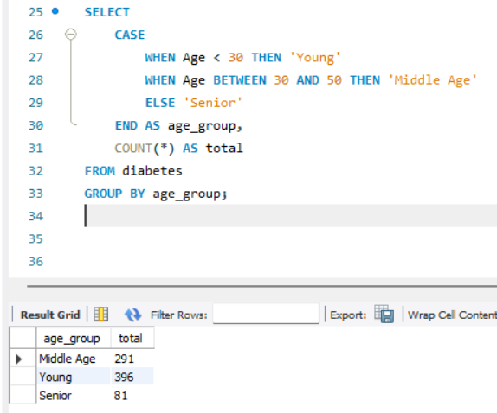
6. Average insulin level
SELECT AVG(Insulin) AS avg_insulin
FROM diabetes;
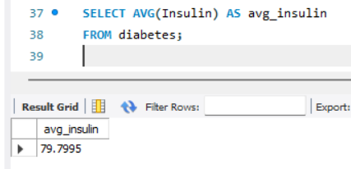
7. Patients with BMI > 30 (obesity threshold)
SELECT *
FROM diabetes
WHERE BMI > 30;
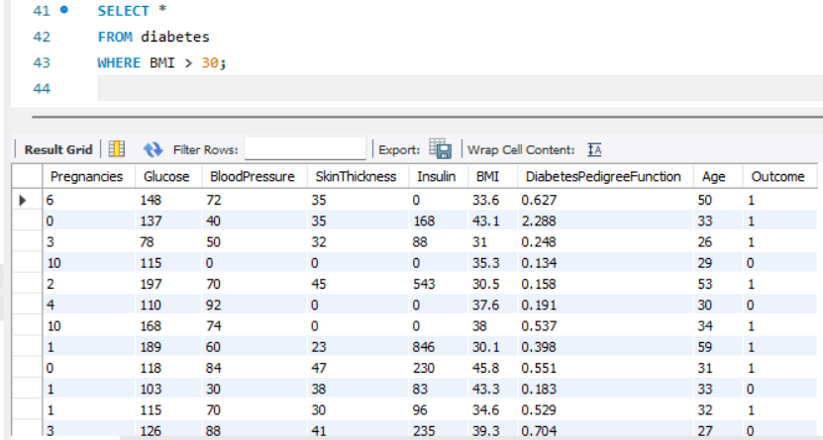
8. Average blood pressure
SELECT AVG(BloodPressure) AS avg_bp
FROM diabetes;
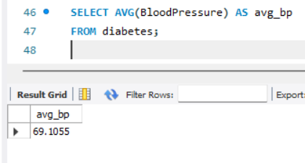

9. Highest glucose values
SELECT *
FROM diabetes
ORDER BY Glucose DESC
LIMIT 10;
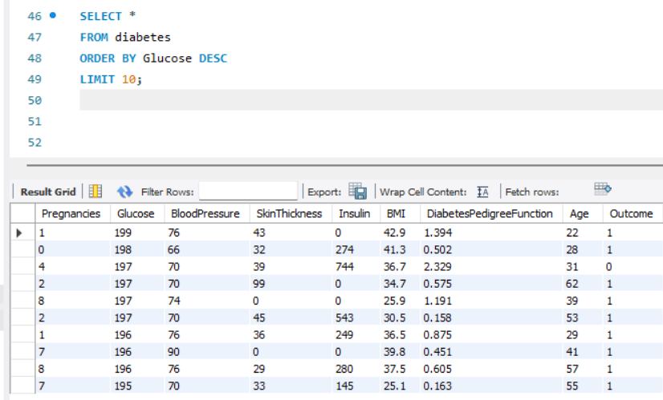
10. Patients with zero insulin values
SELECT *
FROM diabetes
WHERE Insulin = 0;
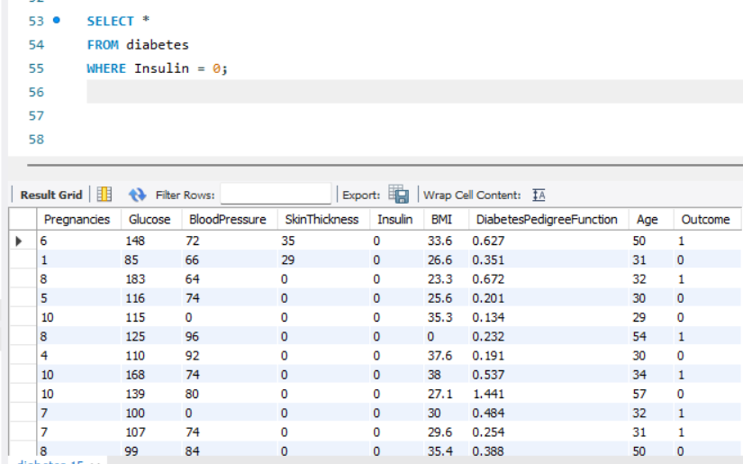
🔥 7. Advanced SQL Analysis (15 Tasks)

1. BMI category segmentation
SELECT
CASE
WHEN BMI < 18.5 THEN 'Underweight'
WHEN BMI BETWEEN 18.5 AND 24.9 THEN 'Normal'
WHEN BMI BETWEEN 25 AND 29.9 THEN 'Overweight'
ELSE 'Obese'
END AS bmi_category,
COUNT(*) AS total
FROM diabetes
GROUP BY bmi_category;
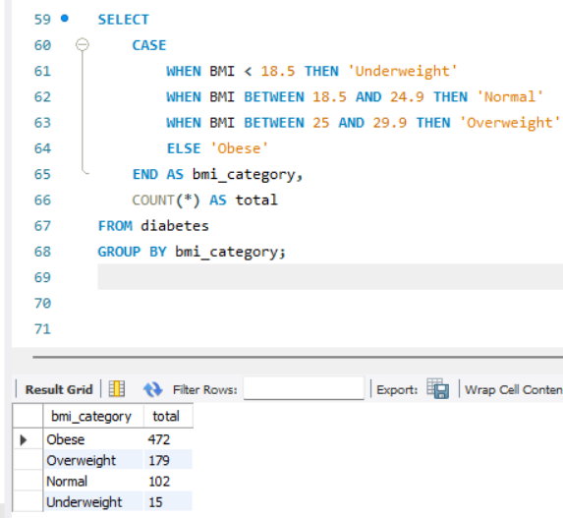
2. Diabetes rate by BMI category
SELECT
CASE
WHEN BMI < 18.5 THEN 'Underweight'
WHEN BMI BETWEEN 18.5 AND 24.9 THEN 'Normal'
WHEN BMI BETWEEN 25 AND 29.9 THEN 'Overweight'
ELSE 'Obese'
END AS bmi_category,
Outcome,
COUNT(*) AS total
FROM diabetes
GROUP BY bmi_category, Outcome;
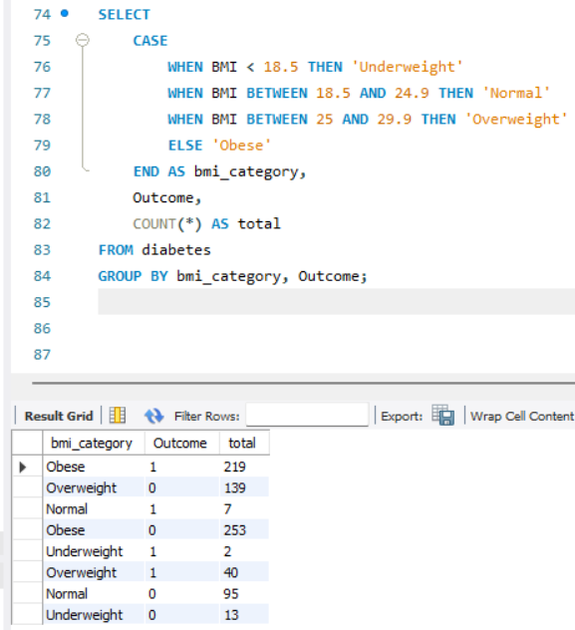
3. Diabetes rate by glucose level
SELECT
CASE
WHEN Glucose < 100 THEN 'Normal'
WHEN Glucose BETWEEN 100 AND 125 THEN 'Prediabetic'
ELSE 'Diabetic Range'
END AS glucose_category,
Outcome,
COUNT(*) AS total
FROM diabetes
GROUP BY glucose_category, Outcome;
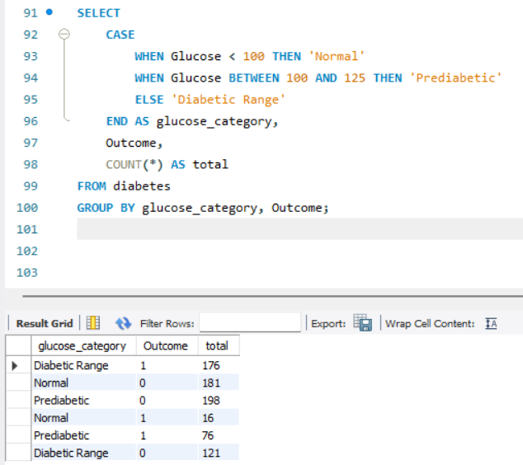

4. Correlation-style check: high BMI + high glucose
SELECT *
FROM diabetes
WHERE BMI > 30 AND Glucose > 140;
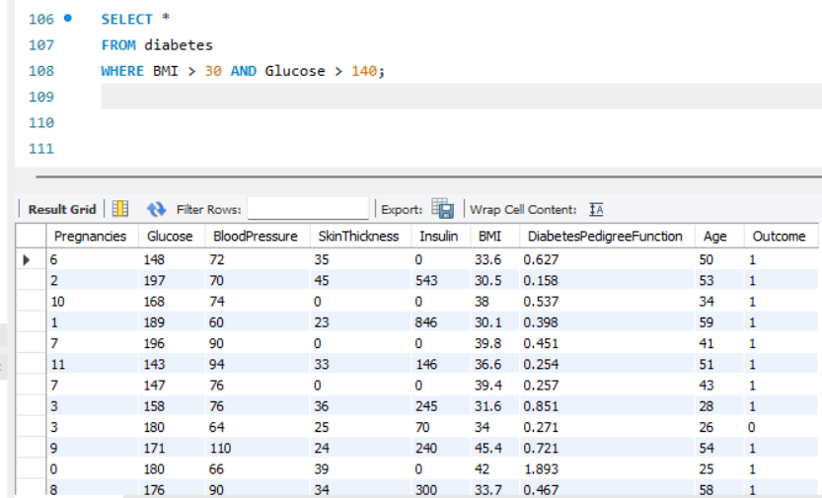
5. Average metrics for diabetic vs non-diabetic
SELECT Outcome,
AVG(Glucose) AS avg_glucose,
AVG(BMI) AS avg_bmi,
AVG(BloodPressure) AS avg_bp
FROM diabetes
GROUP BY Outcome;
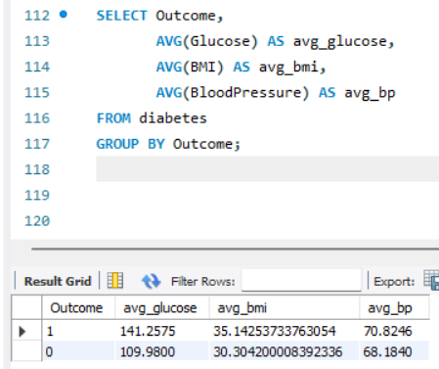
6. Age vs diabetes outcome
SELECT Age, Outcome, COUNT(*) AS total
FROM diabetes
GROUP BY Age, Outcome
ORDER BY Age;
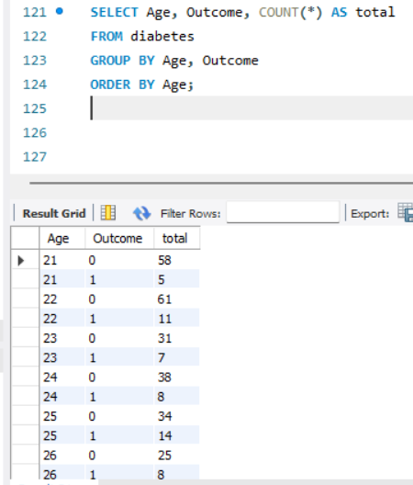

7. Insulin vs glucose relationship (binned)
SELECT
CASE
WHEN Insulin < 50 THEN 'Low Insulin'
WHEN Insulin BETWEEN 50 AND 150 THEN 'Medium Insulin'
ELSE 'High Insulin'
END AS insulin_group,
Outcome,
COUNT(*) AS total
FROM diabetes
GROUP BY insulin_group, Outcome;
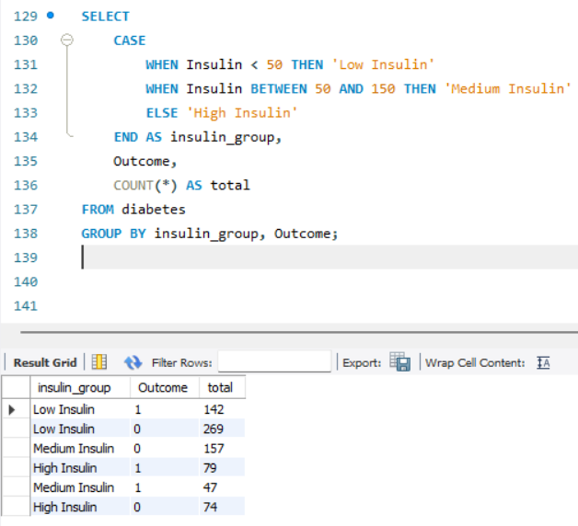
8. High-risk patients (medical heuristic)
SELECT *
FROM diabetes
WHERE Glucose > 150
AND BMI > 35
AND Age > 40;
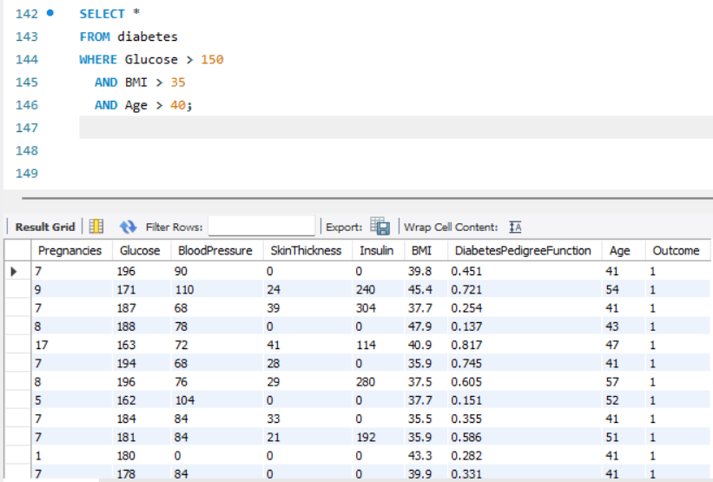

9. Diabetes Pedigree Function segmentation
SELECT
CASE
WHEN DiabetesPedigreeFunction < 0.5 THEN 'Low Genetic Risk'
WHEN DiabetesPedigreeFunction BETWEEN 0.5 AND 1 THEN 'Medium Genetic Risk'
ELSE 'High Genetic Risk'
END AS pedigree_group,
COUNT(*) AS total
FROM diabetes
GROUP BY pedigree_group;
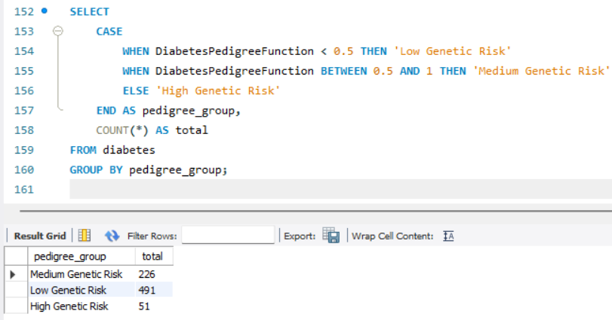

10. Diabetes rate by genetic risk
SELECT
CASE
WHEN DiabetesPedigreeFunction < 0.5 THEN 'Low Genetic Risk'
WHEN DiabetesPedigreeFunction BETWEEN 0.5 AND 1 THEN 'Medium Genetic Risk'
ELSE 'High Genetic Risk'
END AS pedigree_group,
Outcome,
COUNT(*) AS total
FROM diabetes
GROUP BY pedigree_group, Outcome;
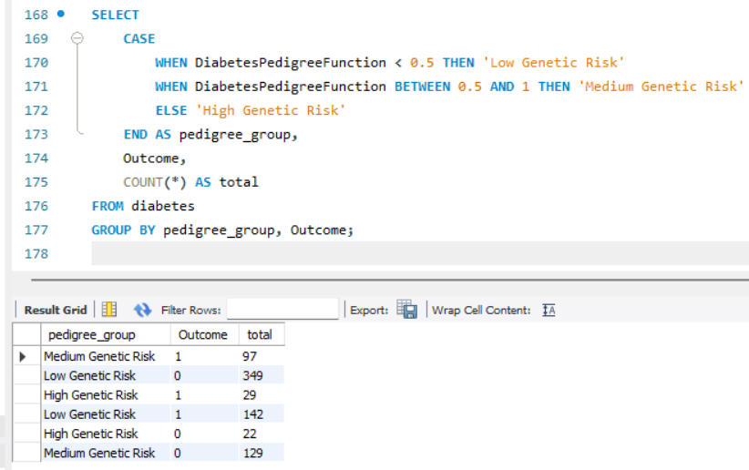

11. Build a “Medical Risk Score”
SELECT
*,
ROUND(Glucose * 0.4 +
BMI * 0.3 +
Age * 0.2 +
DiabetesPedigreeFunction * 10, 2) AS risk_score
FROM diabetes
ORDER BY risk_score DESC;
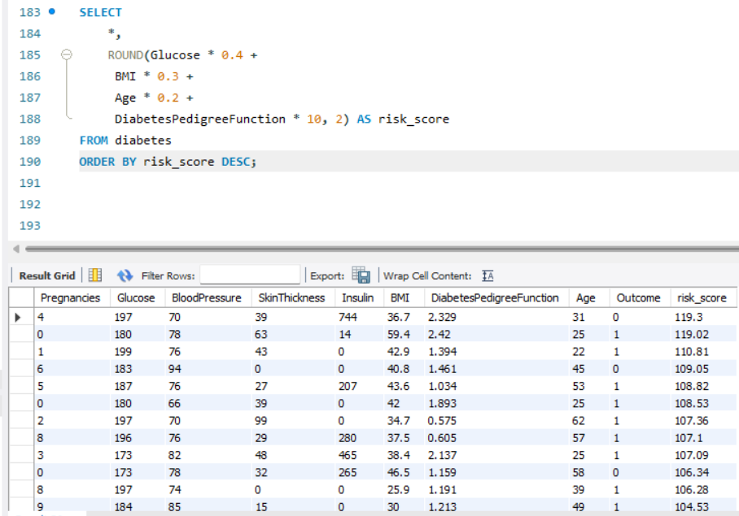

12. Patients with extremely low values (possible missing data)
SELECT *
FROM diabetes
WHERE Glucose = 0
OR BloodPressure = 0
OR BMI = 0;
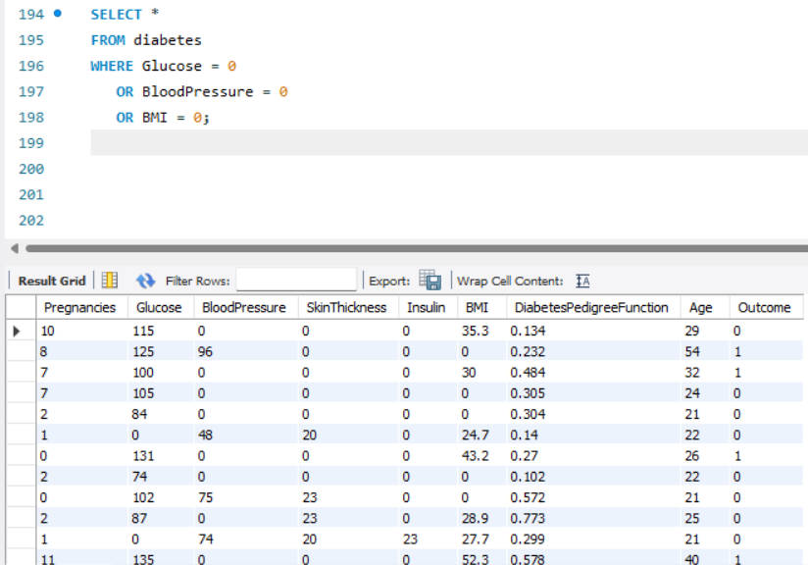

13. Age group vs diabetes outcome
SELECT
CASE
WHEN Age < 30 THEN 'Young'
WHEN Age BETWEEN 30 AND 50 THEN 'Middle Age'
ELSE 'Senior'
END AS age_group,
Outcome,
COUNT(*) AS total
FROM diabetes
GROUP BY age_group, Outcome;
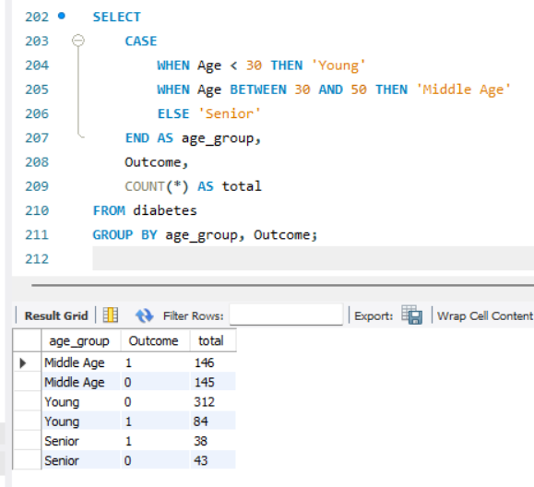
14. Patients with high pedigree function but normal glucose
SELECT *
FROM diabetes
WHERE DiabetesPedigreeFunction > 1
AND Glucose < 120;
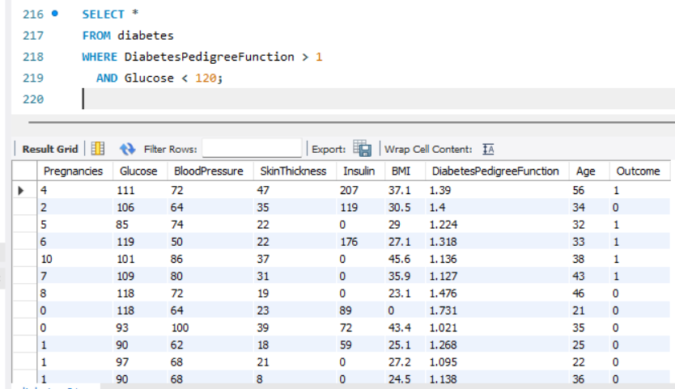

15. Combined risk segmentation
SELECT
CASE
WHEN Glucose > 150 AND BMI > 35 THEN 'Very High Risk'
WHEN Glucose > 130 AND BMI > 30 THEN 'High Risk'
WHEN Glucose > 110 THEN 'Moderate Risk'
ELSE 'Low Risk'
END AS risk_group,
COUNT(*) AS total
FROM diabetes
GROUP BY risk_group;
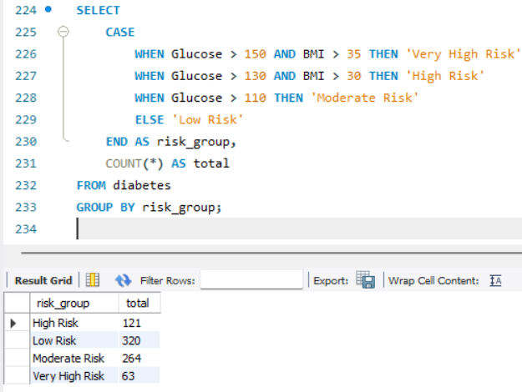

🏁 8. Conclusion
This Diabetes Prediction SQL project provides a complete analysis of medical indicators and their relationship with diabetes.
Through this project, we explored:
- Medical risk factors
- Lifestyle indicators
- Diabetes outcome patterns
- Segmentation and scoring
- Feature engineering for predictive modelling
This project demonstrates strong SQL capabilities, including:
- Data import
- Data validation
- Aggregations and grouping
- Conditional logic
- Medical risk scoring
- Analytical storytelling

